**Egyptian Cotton Trademark Application**

Page **1** of **5**

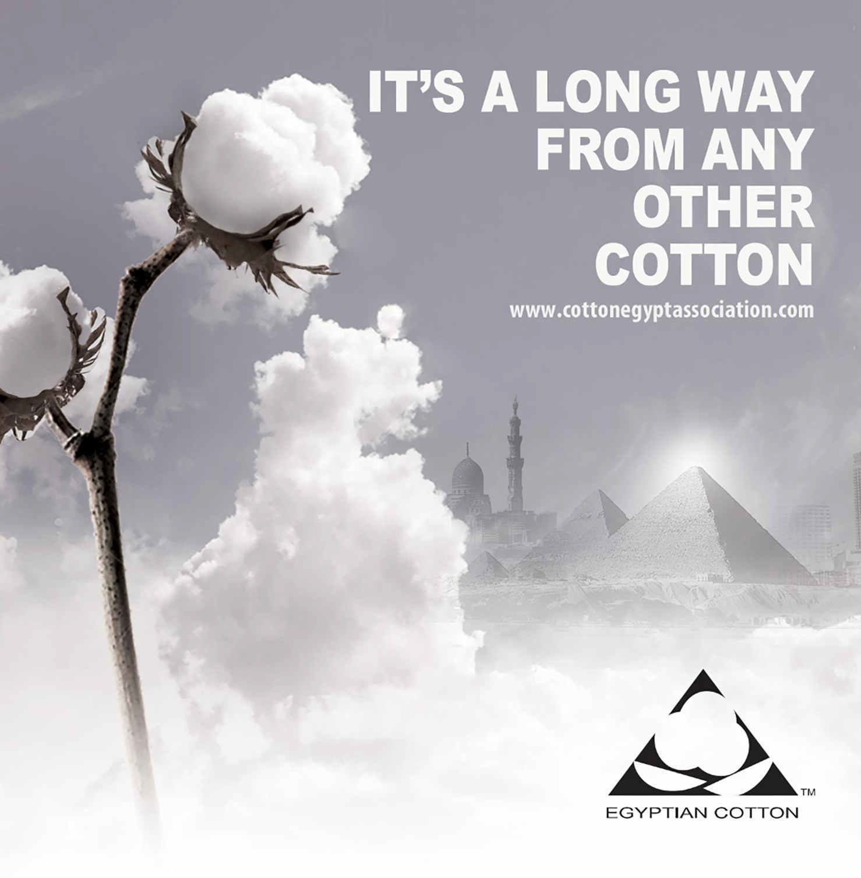

**EGYPTIAN COTTON TRADEMARK APPLICATION**

Company Name: Street Address: Country: City: Postal Code:

Tax registration ID number: ---------------------------------------------------------------------------------------------------------

Telephone: ( ) Fax: ( )

Email: Website: Officer of Company: Additional Contact: Title: Title: E-mail: E-mail: Tel: ( ) Tel: ( )

Date of Application: ------------/-----------/-------------

Industry Classification (Please check all that apply)

Raw Cotton Spinner Weaver Knitter Manufacturer Designer Brand Retailer Department Store Retail Chain Hypermarket

Internet retailing other (please specify):

Egyptian cotton products that need to be licensed (Please check all that apply)

Textiles:

Yarns knit Fabrics

Woven Fabrics

Other:

Home Fashion:

Towels

Sheets Rugs

Blankets

Kitchen Towels

Bath Rob

Bed Linens Curtain Other:

Apparel:

Children Wear Baby / Infant Wear

Men’s: Woven Shirts Heavy Knits Knit Shirts Trousers Jeans

Sweaters Sleep wear Underwear Other (please specify): Women’s: Woven Shirts Heavy knits Shirts Pants Jeans

Sweaters Sleep wear Intimate Apparel Dresses / Skirts Sportswear Woven Classics Hotel Towels Other:

*Products which qualify to have the Cotton Egypt trademark must be made of 100% Egyptian cotton.

**EGYPTIAN COTTON SUPPLIER INFORMATION**

Please state below your supplier of Egyptian cotton fiber and / or product(s) to your company & attach copies of your most recent corresponding contract(s) or invoice(s) to this application. (All suppliers in the value chain must have a valid Egyptian cotton logo license)

# * Supplier Name:

Address:

Email:

Telephone: ( )

|  |  |  |  |
| --- | --- | --- | --- |
| **Type and Specifications of Egyptian cotton Product**  **(Raw cotton/ Yarn/ Fabrics/ Finished goods)** | **Quantity** | **Date** | **Stock Available** |
|  |  |  |  |
|  |  |  |  |
|  |  |  |  |
|  |  |  |  |

# *Supplier Name:

Address:

Email:

Telephone: ( ) _

|  |  |  |  |
| --- | --- | --- | --- |
| **Type and Specifications of Egyptian cotton Product**  **(Raw cotton/ Yarn/ Fabrics/ Finished goods)** | **Quantity** | **Date** | **Stock Available** |
|  |  |  |  |
|  |  |  |  |
|  |  |  |  |
|  |  |  |  |

*In case your esteemed company has more than 2 suppliers please reprint this page.

*Products which qualify to have the Cotton Egypt trademark must be made of 100% Egyptian cotton.

**EGYPTIAN COTTON Subcontractors INFORMATION**

Please state below your Subcontractors of Egyptian cotton product(s) to your company (If Any)

|  |  |  |  |
| --- | --- | --- | --- |
| **Subcontractors Name** | **Process** | **Date** | **Address -**  **Email -**  **Telephone** |
|  |  |  |  |
|  |  |  |  |
|  |  |  |  |

**EGYPTIAN COTTON PRODUCT INFORMATION**

Please state below all the information of your Egyptian cotton products that you are currently supplying.

|  |  |  |  |  |  |
| --- | --- | --- | --- | --- | --- |
| **Type of Egyptian Cotton Product** | **Quantity** | **Buyer's Name**  **&/or Brand Name** | **Stores where products are**  **sold** | **Date** | **Address/Country/City** |
|  |  |  |  |  |  |
|  |  |  |  |  |  |
|  |  |  |  |  |  |
|  |  |  |  |  |  |
|  |  |  |  |  |  |
|  |  |  |  |  |  |
|  |  |  |  |  |  |
|  |  |  |  |  |  |
|  |  |  |  |  |  |
|  |  |  |  |  |  |
|  |  |  |  |  |  |
|  |  |  |  |  |  |
|  |  |  |  |  |  |
|  |  |  |  |  |  |

**COMMITMENT FORM**

I the legal representative of

**Hereby confirm that all the information in the above application form is true to the best of my knowledge and I authorize Cotton Egypt to verify this information with the above mentioned sources (sponsors). I am also committing my company to the timely delivery of further information with regard to my purchases and use of Egyptian cotton as well as to facilitate Cotton Egypt’s enquiries with my sponsors by submitting proofs of purchase from the sponsors.**

**I also understand that Cotton Egypt reserves the right to reject this application should my company’s operation not meet their industry standards requirements for the licensing of the Egyptian Cotton Logo TM**

For and on behalf of:

COMPANY NAME Application Date

REPRESENTATIVE NAME TITLE

SIGNATURE COMPANY SEAL

All information in this application form is for the own usage of Cotton Egypt Association and will not be shared by any third party unless approved by the applicant.